chapter 1
INTRODUCTION
1.1 Introduction:

Today the development of artificial intelligence (AI) systems that can organize a natural human-machine interaction (through voice, communication, gestures, facial expressions, etc.) is gaining in popularity. One of the most studied and popular was the direction of interaction, based on the understanding of the machine by the machine of the natural human language. It is no longer a human who learns to communicate with a machine, but a machine learns to communicate with a human, exploring his actions, habits, behavior and trying to become his personalized assistant.
Virtual assistants are software programs that help you ease your day-to-day tasks, such as showing weather reports, creating remainders, making shopping lists, etc. They can take commands via voice. Voice-based intelligent assistants need an invoking word or wake word to activate the listener, followed by the command. We have so many virtual assistants, such as Apple’s Siri, Amazon’s Alexa, and Microsoft’s Cortana.
This system is designed to be used efficiently on desktops. Personal assistant software improves user productivity by managing routine tasks of the user and by providing information from an online source to the user.
This project was started on the premise that there is a sufficient amount of openly available data and information on the web that can be utilized to build a virtual assistant that has access to making intelligent decisions for routine user activities.

1.2 Motivation:

To Start the trend of customized voice Assistant that does our work with a single voice command and some companies like Samsung, One+, Sony, are creating their own Assistant instead of Google Assistant. So, this motivated me to do this project.
1.3 Objective of Thesis
The main objective of this project is to start the trend of making a customized Voice Assistant that automates one’s own routine and personal work and accesses the work through a single command.
This project has both frontend and backend and it’s very interactive and can understand Natural Language like English-IN.

1.4 Organization of Thesis
The rest of the thesis is organized in the following manner:
Chapter 2 -Deals with Literature Survey.
Chapter 3 - Contains the proposed work and analysis.
Chapter 4 -Gives the detailed description of Modules using UML Diagrams.
Chapter 5 -Gives the Implementation details, which the hardware and software requirements, description of the Technologies used.
Chapter 6 -Deals with the Debugging process of the proposed system.
Chapter 7 - Here the results of the implemented modules along with the respectivescreen shots are provided.
Chapter 8 - Here the Conclusions of the current application are provided.
Chapter 9 - Here the enhancement work for the future research are given.
Chapter 10 - Here the References, Text Books, Web Sites for this work are given.
Chapter 11- Here the publication details are given.

chapter 2
Literature survey
2.1 Basic Concepts:
“Personal Voice Assistant” is mainly used to do routine and boring works with one single voice command.
2.2 RELATED WORK:
Each company developer of the intelligent assistant applies his own specific methods and approaches for development, which in turn affects the final product. One assistant can synthesize speech more qualitatively, another can more accurately and without additional explanations and corrections perform tasks, others can perform a narrower range of tasks, but most accurately and as the user wants. Obviously, there is no universal assistant who would perform all tasks equally well. The set of characteristics that an assistant has depends entirely on which area the developer has paid more attention to. Since all systems are based on machine learning methods and use for their creation huge amounts of data collected from various sources and then trained on them, an important role is played by the source of this data, be it search systems, various information sources or social networks. The amount of information from different sources determines the nature of the assistant, which can result as a result. Despite the different approaches to learning, different algorithms and techniques, the principle of building such systems remain approximately the same. Figure 2.1 shows the technologies that are used to create intelligent systems of interaction with a human by his natural language. The main technologies are voice activation, automatic speech recognition, Teach-To-Speech, voice biometrics, dialogue manager, natural language understanding and named entity recognition.
Voice Technology | Brain Technology
Voice Activation | Voice Bio-metrics
Automatic Speech Recognition (ASR) | Dialog Management
(Teach-To-Speech (TTS) | Natural Language Understanding (NLU)  Named Entity Recognition NER)
Table2.1: Comparison between Voice Technology and Brain Technology

2.2.1 INTRODUCTION TO PYTHON:
Python is an OOPs (Object Oriented Programming) based, high level, interpreted programming language. It is a robust, highly useful language focused on rapid application development (RAD). Python helps in the easy writing and execution of codes. Python can implement the same logic with as much as 1/5th code as compared to other OOPs languages. Python provides a huge list of benefits to all. The usage of Python is such that it cannot be limited to only one activity. Its growing popularity has allowed it to enter into some of the most popular and complex processes like Artificial Intelligence (AI), Machine Learning (ML), Natural Language Processing (NLP), Data Science (DS), etc. Python has a lot of libraries for every need of this project. For Nemo, libraries used are speech recognition to recognize the voice, Pyttsx for text to speech, selenium for web automation, etc. Python is reasonably efficient. Efficiency is usually not a problem for small examples. If your Python code is not efficient enough, a general procedure to improve it is to find out what is taking most of the time and implement just that part more efficiently in some lower-level languages. This will result in much less programming and more efficient code (because you will have more time to optimize) than writing everything in a low-level language

2.2.2 INTRODUCTION TO SPEECH RECOGNIZATION:

Methodology of Virtual Assistant Using Python
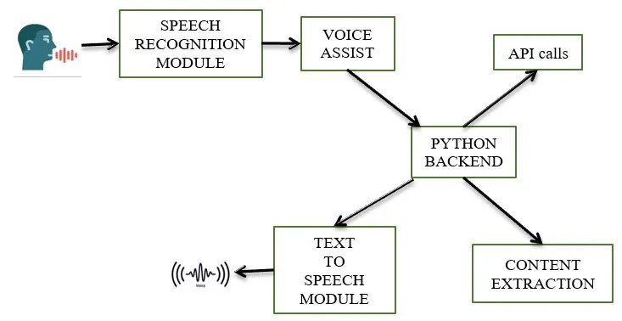
Fig 2.2 Detailed workflow Of Voice Assistant

Speech Recognition module
The system uses Google’s online speech recognition system for converting speech input to text. The speech input Users can obtain texts from the special corpora organized on the computer network server at the information center from the microphone is temporarily stored in the system which is then sent to Google cloud for speech recognition. The equivalent text is then received and fed to the central processor.

Python Backend:
The python backend gets the output from the speech recognition module and then identifies whether the command or the speech output is an API Call and Context Extraction. The output is then sent back to the python backend to give the required output to the user.

API calls
API stands for Application Programming Interface. An API is a software intermediary that allows two applications to talk to each other. In other words, an API is a messenger that delivers your request to the provider that you’re requesting it from and then delivers the response back to you.

Content Extraction
Context extraction (CE) is the task of automatically extracting structured information from unstructured and/or semi-structured machine-readable documents. In most cases, this activity concerns processing human language texts using natural language processing (NLP). Recent activities in multimedia document processing like automatic annotation and content extraction out of images/audio/video could be seen as context extraction TEST RESULTS.

Text-to-speech module
Text-to-Speech (TTS) refers to the ability of computers to read text aloud. A TTS Engine converts written text to a phonemic representation, then converts the phonemic representation to waveforms that can be output as sound. TTS engines with different languages, dialects and specialized vocabularies are available through third-party publishers.
2.2 EXISTING SYSTEM:
- In the Existing system, we had used google, Siri voice Assistant as a reference and took packages from those open-source python library.
- It's difficult to do the task to automate that system to take notes, auto shutdown, screen recording, selfie,..., by using voice command ,To overcome this we propose the implementation of using file handling, OS package ,…,

chapter 3
PROPOSED WORK & Analysis
3.1 Problem Definition
- This Project aims for Customized voice Assistant.
3.2 Proposed Solution
The work started with analyzing the audio commands given by the user through the microphone. This can be anything like getting any information, operating a computer’s internal files, etc. This is an empirical qualitative study, based on reading above mentioned literature and testing their examples. Tests are made by programming according to books and online resources, with the explicit goal to find best practices and a more advanced understanding of Voice Assistant.
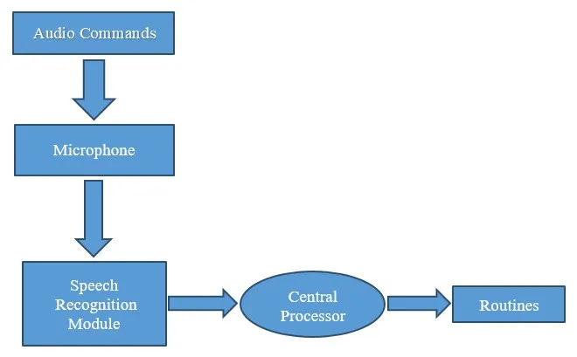
Fig.3.1 Basic Workflow of Our voice assistant

Fig.3.1 shows the workflow of the basic process of the voice assistant. Speech recognition is used to convert the speech input to text. This text is then fed to the central processor which determines the nature of the command and calls the relevant script for execution.
But the complexities don’t stop there. Even with hundreds of hours of input, other factors can play a huge role in whether or not the software can understand you. Background noise can easily throw a speech recognition device off track. This is because it does not inherently have the ability to distinguish the ambient sounds it “hears” of a dog barking or a helicopter flying overhead, from your voice. Engineers have to program that ability into the device; they conduct data collection of these ambient sounds and “tell” the device to filter them out. Another factor is the way humans naturally shift the pitch of their voice to accommodate for noisy environments; speech recognition systems can be sensitive to these pitch changes.

3.3 Feasibility Study
Feasibility study can help you determine whether or not you should proceed with your project. It is essential to evaluate cost and benefit of the proposed system. Five types of feasibility study are taken into consideration.
1.Technical Feasibility: It includes finding out technologies for the project, Both Hardware and Software. For virtual assistant, user must have microphone to convey their message and a speaker to listen when system speaks. These are very cheap and everyone generally possess them. Besides, system needs internet connection. It is also not an issue in this era where almost every home or office has Wi-Fi.
2.Operational Feasibility: It is the ease and simplicity of operation of proposed system. System does not require any special skill set for users to operate it. In fact, it is designed to be used by almost everyone. Kids who still don’t know to write can read out problems for system and get answers.
3.Economical Feasibility: Here, we find the total cost and benefit of the proposed system over the current system. For this project, the main cost is documentation cost. User also should have to pay for microphone and speakers. Again, they are cheap and available. As far as maintenance is concerned, Nemo won’t cost too much.
4.Organizational Feasibility: This shows the management and organizational structure of the project.
5.Cultural Feasibility: It deals with compatibility of the project with cultural environment. Virtual assistant is built according with the general culture.
This project is technically feasible with no external hardware requirements. Also it is simple in operation and does not cost training and repairs. Overall feasibility study of the project reveals that the goals of the proposed system are achievable Decision is taken to proceed with the project.

CHAPTER 4
design
4.1 System Design
The project contains the following modules

Speech Recognition module
The system uses Google’s online speech recognition system for converting speech input to text. The speech input Users can obtain texts from the special corpora organized on the computer network server at the information center from the microphone is temporarily stored in the system which is then sent to Google cloud for speech recognition. The equivalent text is then received and fed to the central processor.

Python Backend:
The python backend gets the output from the speech recognition module and then identifies whether the command or the speech output is an API Call and Context Extraction. The output is then sent back to the python backend to give the required output to the user.

API calls
API stands for Application Programming Interface. An API is a software intermediary that allows two applications to talk to each other. In other words, an API is a messenger that delivers your request to the provider that you’re requesting it from and then delivers the response back to you.

Content Extraction
Context extraction (CE) is the task of automatically extracting structured information from unstructured and/or semi-structured machine-readable documents. In most cases, this activity concerns processing human language texts using natural language processing (NLP). Recent activities in multimedia document processing like automatic annotation and content extraction out of images/audio/video could be seen as context extraction TEST RESULTS.

Text-to-speech module
Text-to-Speech (TTS) refers to the ability of computers to read text aloud. A TTS Engine converts written text to a phonemic representation, then converts the phonemic representation to waveforms that can be output as sound. TTS engines with different languages, dialects and specialized vocabularies are available through third-party publishers.
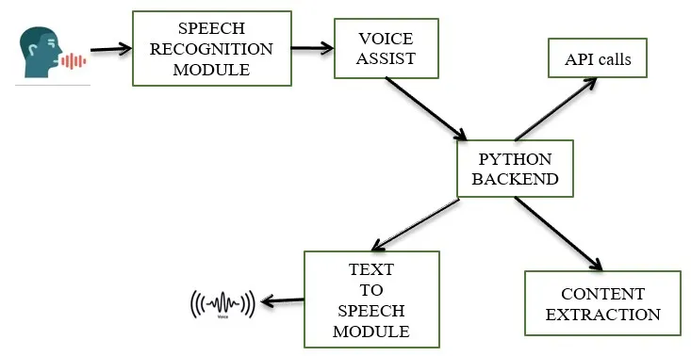

figure 4.1 Block diagram for voice assistant

4.2 UML DIAGRAMS
4.2.1 UML Data
The UML’s four structural diagram exists to visualize, specify, construct and document the static aspects of system. Just as the static aspects of a house encompass the existence and placement of such things as walls, doors, windows, pipes, wires and vents. So to do the static aspects of a software system encompass the existence and placement of such things classes, interfaces, collaborations, components and nodes.
The Unified Modeling Language (UML) is used to specify, visualize, modify, construct and document the art effects of an object-oriented software intensive system under development. UML offers a standard way to visualize a system's architectural blueprints, including elements such as:
- actors
- business processes
- (logical) components
- activities
- programming language statements
- database schemas, and
- Reusable software components.
UML combines best techniques from data modeling (entity relationship diagrams), business modeling (work flows), object modeling, and component modeling. It can be used with all processes, throughout the software development life cycle, and across different implementation technologies.

UML has synthesized the notations of the Booth method, the Object-modeling technique (OMT) and Object-oriented software engineering (OOSE) by fusing them into a single, common and widely usable modeling language. UML aims to be a standard modeling language which can model concurrent and distributed systems.

4.2.2 Use case diagram
In the Unified Modeling Language (UML), a use case diagram can summarize the details of your system's users (also known as actors) and their interactions with the system UML use case diagrams are ideal for:
- Representing the goals of system-user interactions
- Defining and organizing functional requirements in a system
- Specifying the context and requirements of a system
- Modelling the basic flow of events in a use case
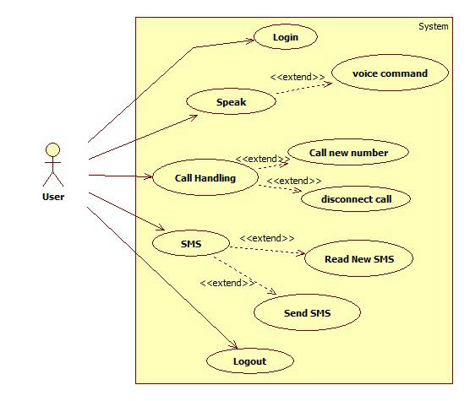
Figure 4.2 Use case diagram for our voice assistant

4.2.3 Sequence Diagram
Sequence Diagrams Represent the objects participating the interaction horizontally and time vertically. A Use Case is a kind of behavioral classifier that represents a declaration of an offered behavior. Each use case specifies some behavior, possibly including variants that the subject can perform in collaboration with one or more actors. Use cases define the offered behavior of the subject without reference to its internal structure. These behaviors, involving interactions between the actor and the subject, may result in changes to the state of the subject and communications with its environment. A use case can include possible variations of its basic behavior, including exceptional behavior and error handling.

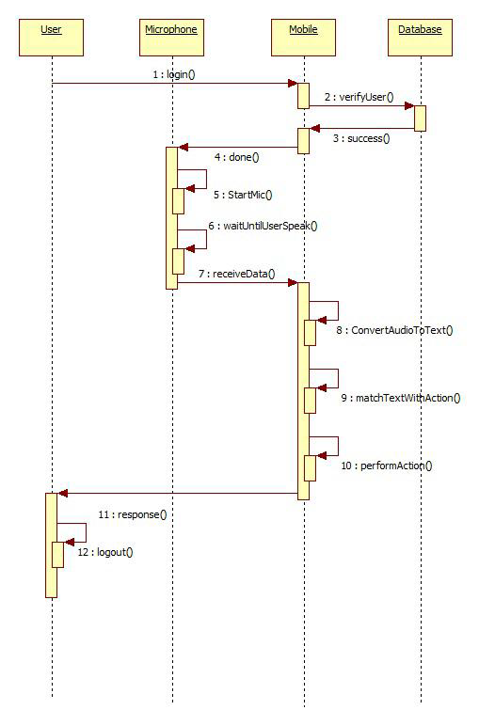
Figure 4.3 Sequence Diagram for voice assistant
CHAPTER 5
Implementation
Implementation is the stage of the project when the theoretical design is turned out into a working system. Thus, it can be considered to be the most critical stage in achieving a successful new system and in giving the user, confidence that the new system will work and be effective.
The implementation stage involves careful planning, investigation of the existing system and its constraints on implementation, designing of methods to achieve changeover and evaluation of changeover methods.
5.1 Software Requirements
- Python idle
5.2 Hardware Requirements
- System
- 4 GB of RAM
- 500 GB of Hard disk
5.3 Technologies Used
5.3.1 Python
- Python is fast: Python has developed a reputation as a solid, high-performance language. Lots has been done in recent years to get to this point. The PyPy project aims to speed up Python as a whole (and is doing a great job of it). And Numba is another tool that can offer amazing speedups by implementing high performance functions written directly in Python.

- Python has broad support: The applications for Python are broad and varied; it’s used by individuals and big industry players alike in everything from systems automation, testing, and ETL to gaming, CGI and web development. Disney uses Python to help power their creative process. And Mozilla releases tons of open-source packages built in Python. Bank of America uses Python to build new products and interfaces within the bank’s technology infrastructure.
- Ease of use: Python gets a lot of accolades for being easy to learn, and rightfully so. The learning curve is very gradual. Other languages can be quite steep. Python places a heavy emphasis on readability, as shown by its comparison with other object-oriented languages.
5.3.2 Python Versions:
- Python 2.0 was released on 16 October 2000 and had many major new features, including a cycle-detecting, garbage collector, and support for Unicode. With this release, the development process became more transparent and community-backed.
- Python 3.0 (initially called Python 3000 or py3k) was released on 3 December 2008 after a long testing period. It is a major revision of the language that is not completely backward-compatible with previous versions. However, many of its major features have been back ported to the Python 2.6.x and 2.7.x version series, and releases of Python 3 include the 2to3 utility, which automates the translation of Python 2 code to Python 3.
- Python 2.7's end-of-life date (a.k.a. EOL, sunset date) was initially set at 2015, then postponed to 2020 out of concern that a large body of existing code could not easily be forward-ported to Python 3.In January 2017, Google announced work on a Python 2.7 to go Trans compiler to improve performance under concurrent workloads.

5.3.3 Python idle
- IDLE is Python’s Integrated Development and Learning Environment. It allows programmers to easily write Python code. Just like Python Shell, IDLE can be used to execute a single statement and create, modify, and execute Python scripts.
- IDLE provides a fully-featured text editor to create Python scripts that include features like syntax highlighting, autocompletion, and smart indent. It also has a debugger with stepping and breakpoints features. This makes debugging easier.
- IDLE is Python’s Integrated Development and Learning Environment. It allows programmers to easily write Python code. Just like Python Shell, IDLE can be used to execute a single statement and create, modify, and execute Python scripts.
- IDLE provides a fully-featured text editor to create Python scripts that include features like syntax highlighting, auto completion, and smart indent. It also has a debugger with stepping and breakpoints features. This makes debugging easier.
In IDLE, we write code line by line. Each specific line will handle one thing, and you can type whatever you want in that line and press enter to execute it. IDLE works more like a terminal or command prompt - You write one line, press enter, it executes.
5.4 Implementation of Modules:
5.4.1 List of Modules
List of Modules:
- Pyttsx3
- Tkinter
- Wikipedia
- Speech Recognition
5.4.1.1Pyttsx3:
This module is used for the conversion of text to speech in a program it works offline. To install this module type the below command in the terminal.
pip install pyttsx3
5.4.1.2 Tkinter:
- This module is used for building GUI and comes inbuilt with Python. This module comes built-in with Python.
5.4.1.3 Wikipedia:
- As we all know Wikipedia is a great source of knowledge just like GeeksforGeeks we have used the Wikipedia module to get information from Wikipedia or to perform a Wikipedia search.
- To install this module type the below command in the terminal
- pip install wikipedia
5.4.1.4 Speech Recognition:
Since we’re building an Application of voice assistant, one of the most important things in this is that your assistant recognizes your voice (means what you want to say/ ask).
To install this module type the below command in the terminal.
pip install SpeechRecognition

5.5 Coding:
from tkinter import * #to create GUI Interface of an application
import cv2 #computer vision package related to matlab in python
import PIL.Image, PIL.ImageTk
import pyttsx3 #used to convert text to speech
import datetime #used to retrive date and time
import speech_recognition as sr #used to convert speech to text and give command to Assistant
import pyautogui# pip install pyautogui
import wikipedia #allows us to search a query supplied as an argument
import webbrowser #provides a high-level interface to allow displaying Web-based documents to users
import os #module provides functions for interacting with the operating system
import random #module to generate random numbers
import pyjokes #pip install pyjokes To generate some random jokes
import smtplib
import requests # to either retrieve data from a specified URI or to push data to a server
import roman #helps us convert roman numerals into decimal number and decimal number into roman numerals
import winshell #
import ctypes #
#from Class1 import Student
#import pytesseract
from PIL import Image
import psutil# pip install psutil

#pytesseract.pytesseract.tesseract_cmd = r"C:\Users\mridu\AppData\Local\Tesseract-OCR\tesseract.exe"

numbers = {'hundred':100, 'thousand':1000, 'lakh':100000} #this dictionary helps to conver numbers in string(alphobetic form) to integer form
a = {'name':'jayaprakashrayani@gmail.com'}
engine = pyttsx3.init('sapi5')
voices = engine.getProperty('voices')
engine.setProperty('voice', voices[0].id)
cwd = os.getcwd()

window = Tk() #initializing window /pannel object

global var
global var1

var = StringVar()
var1 = StringVar()

#to convert text file to voice this function is created
def speak(audio):
engine.say(audio)#here audio variable refers to string and the text will be converted to audio
engine.runAndWait()

#this update function is used to refresh / update the Interface
def update(ind):
frame = frames[(ind)%100]
ind += 1
label.configure(image=frame)
window.after(100, update, ind)
'''
#to send mail we use this function which contains a security less mail id and password
def sendemail(to, content):
server = smtplib.SMTP(host='smtp.gmail.com', port=587) #we are configuring server with server's IP and port number
server.ehlo()#------
server.starttls()
server.login('18F01A05C0.ansn@apssdc.info@gmail.com','9398697771') # email id - use any email id whose security/privacy is off
server.sendmail('18F01A05C0.ansn@apssdc.info@gmail.com', to, content)
server.close()
'''
#to take a screenshot of the entire screen we use this function
def screenshot():
img= pyautogui.screenshot()
img.save(cwd +'\\sample.png')#to save the screenshot at D drive
"""This Project Was Done By Anupama and Jaya Prakash Narayana"""
#wishme() is used to wish the user according to the time
def wishme():
hour = int(datetime.datetime.now().hour)
if hour >= 0 and hour <= 12:
var.set("Good Morning User")
window.update()
speak("Good Morning user!")
elif hour >= 12 and hour <= 18:
var.set("Good Afternoon user!")
window.update()
speak("Good Afternoon user!")
else:
var.set("Good Evening user")
window.update()
speak("Good Evening user!")
speak("Myself Nemo How may I help you sir") #BotName - Give a name to your assistant
# to convert speech to text we use this command
def takeCommand():
r = sr.Recognizer()
with sr.Microphone() as source:
var.set("Listening...")
window.update()
print("Listening...")
r.pause_threshold = 1
r.energy_threshold = 400
audio = r.listen(source)
try:
var.set("Recognizing...")
window.update()
print("Recognizing")
query = r.recognize_google(audio, language='en-in')
except Exception as e:
return "None"
var1.set(query)
window.update()
return query
# to get cpu info we use this function
def cpu():
usage = str(psutil.cpu_percent())
speak("cpu is at"+usage)
batrey = psutil.sensors_battery()
speak("Battrey is at")
speak(batrey.percent)

def jokes():
speak(pyjokes.get_joke())#Here we get random jokes from pyjokes library database

# The actual excecution starts here when the user click play button this function starts executing
def play():
btn2['state'] = 'disabled' #initially buttons are disabled
btn0['state'] = 'disabled' #initially buttons are disabled
btn1.configure(bg = 'orange')#here orange represented that our mouse pointer points that particular button
wishme()
while True:
btn1.configure(bg = 'orange')
query = takeCommand().lower()
if 'exit' in query:
var.set("Bye sir")
btn1.configure(bg = '#5C85FB')
btn2['state'] = 'normal'
btn0['state'] = 'normal'
window.update()
speak("Bye sir")
break

elif 'about' in query:
if 'open wikipedia' in query:
webbrowser.open('wikipedia.com')
else:
try:
speak("searching wikipedia")
query = query.replace("according to wikipedia", "")
results = wikipedia.summary(query, sentences=2)
speak("According to wikipedia")
var.set(results)
window.update()
speak(results)
except Exception as e:
var.set('sorry sir could not find any results')
window.update()
speak('sorry sir could not find any results')

elif 'open youtube' in query:
var.set('opening Youtube')
window.update()
speak('opening Youtube')
webbrowser.open("youtube.com")

elif 'open coursera' in query:
var.set('opening course era')
window.update()
speak('opening course era')
webbrowser.open("coursera.com")

elif 'open google' in query:
var.set('opening google')
window.update()
speak('opening google')
webbrowser.open("google.com")

elif 'hello' in query:
var.set('Hello Sir...!')
window.update()
speak("Hello Sir How Can I help You")

elif 'time' in query:
strtime = datetime.datetime.now().strftime("%H:%M:%S")
var.set("Sir the time is %s" % strtime)
window.update()
speak("Sir the time is %s" %strtime)
elif 'wikipedia' in query:
speak("searching...")
query = query.replace("wikipedia ","")
result =wikipedia.summary(query,sentences =2)
speak(result)

elif 'date' in query:
strdate = datetime.datetime.today().strftime("%d %m %y")
var.set("Sir today's date is %s" %strdate)
window.update()
speak("Sir today's date is %s" %strdate)

elif 'thank you' in query:
var.set("Welcome Sir")
window.update()
speak("Welcome Sir")

elif 'can you do for me' in query:
var.set('I can do multiple tasks for you sir. tell me whatever you want to perform sir')
window.update()
speak('I can do multiple tasks for you sir. tell me whatever you want to perform sir')

elif 'old are you' in query:
var.set("I am a little baby sir")
window.update()
speak("I am a little baby sir")

elif 'screenshot' in query:
screenshot()
speak("screenshot has been saved")

elif 'lock window' in query:
speak("locking the device")
ctypes.windll.user32.LockWorkStation()
elif 'empty recycle bin' in query:
winshell.recycle_bin().empty(confirm = False, show_progress = False, sound = True)
speak("Recycle Bin Recycled")
elif "where is" in query:
query = query.replace("where is", "")
location = query
speak("User asked to Locate")
speak(location)
webbrowser.open("https://www.google.nl/maps/place/" + location + "")

elif 'your name' in query:
var.set("Myself Nemo Sir")
window.update()
speak('myself Nemo sir')

elif 'note' in query:
speak("What should I remember sir...!")
data = takeCommand()
speak("you said me to remember that"+data)
remember = open('data.txt','w')
remember.write(data)
remember.close()

elif 'data file' in query:
textnote = open('data.txt','r')
speak("The text note you have is"+textnote.read())

elif 'shutdown' in query:
os.system("shutdown /s /t 1")

elif 'who created you' in query:
var.set('My Creator is Anupama , JayaPrakash and team')
window.update()
speak('My Creator is Anupama , JayaPrakash and team')

elif 'say hello' in query:
var.set('Hello Everyone! My self Nemo')
window.update()
speak('Hello Everyone! My self Nemo')
elif 'open chrome' in query:
var.set("Opening Google Chrome")
window.update()
speak("Opening Google Chrome")
path = "C:\\Program Files (x86)\\Google\\Chrome\\Application\\chrome.exe" #Enter the correct Path according to your system
os.startfile(path)

elif 'email to me' in query:
try:
var.set("What should I say")
window.update()
speak('what should I say')
content = takeCommand()
to = a['name']
sendemail(to, content)
var.set('Email has been sent!')
window.update()
speak('Email has been sent!')

except Exception as e:
print(e)
var.set("Sorry Sir! I was not able to send this email")
window.update()
speak('Sorry Sir! I was not able to send this email')

elif "open python" in query:
var.set("Opening Python Ide")
window.update()
speak('opening python Ide')
os.startfile('C:\\Users\\mridu\\AppData\\Roaming\\Microsoft\\Windows\\Start Menu\\Programs\\Python 3.7\\IDLE (Python 3.7 64-bit)') #Enter the correct Path according to your system

elif 'open code blocks' in query:
var.set('Opening Codeblocks')
window.update()
speak('opening Codeblocks')
os.startfile("C:\\Program Files (x86)\\CodeBlocks\\codeblocks.exe") #Enter the correct Path according to your system

elif 'open anaconda' in query:
var.set('Opening Anaconda')
window.update()
speak('opening anaconda')
os.startfile("C:\\Users\\mridu\\AppData\\Roaming\\Microsoft\\Windows\\Start Menu\\Programs\\Anaconda3 (64-bit)\\Anaconda Navigator") #Enter the correct Path according to your system
elif 'calculation' in query:
sum = 0
var.set('Yes Sir, please tell the numbers')
window.update()
speak('Yes Sir, please tell the numbers')
while True:
query = takeCommand()
if 'answer' in query:
var.set('here is result'+str(sum))
window.update()
speak('here is result'+str(sum))
break
elif query:
if query == 'x**':
digit = 30
elif query in numbers:
digit = numbers[query]
elif 'x' in query:
query = query.upper()
digit = roman.fromRoman(query)
elif query.isdigit():
digit = int(query)
else:
digit = 0
sum += digit

elif 'student details' in query:
var.set('Name of the student')
window.update()
speak('Name of the student')
name = takeCommand()
var.set('standard in which he/she study')
window.update()
speak('standard in which he/she study')
standard = takeCommand()
var.set('Role Number')
window.update()
speak('Role number')
rollno = takeCommand()
var.set('Details are saved')
window.update()
speak('Details are saved')
elif 'saved details' in query:
var.set('Name: '+name+' Standard: '+ standard+' Roll No.: '+ rollno)
window.update()
speak('Name: '+name+' Standard: '+ standard+' Roll No.: '+ rollno)

elif 'selfie' in query:
stream = cv2.VideoCapture(0)
grabbed, frame = stream.read()
if grabbed:
#cv2.imshow('pic', frame)
cv2.imwrite('selfie.jpg',frame)
speak('Selfie Saved')
stream.release()
elif 'restart' in query:
os.system("shutdown /r /t 1")

elif 'record video' in query:
cap = cv2.VideoCapture(0)
out = cv2.VideoWriter('output.avi', -1, 20.0, (640,480))
while(cap.isOpened()):
ret, frame = cap.read()
if ret:

out.write(frame)

cv2.imshow('frame',frame)
if cv2.waitKey(1) & 0xFF == ord('q'):
break
else:
break
cap.release()
out.release()
cv2.destroyAllWindows()
elif 'read the photo' in query: #If you have Pytesseract installed for Optical Character Recognition
try:
im = Image.open('selfie.jpg')
text = pytesseract.image_to_string(im)
speak(text)
except Exception as e:
print("Unable to read the data")
print(e)

elif 'CPU info' in query:
cpu()
elif 'joke' in query:
jokes()
elif 'empty recycle bin' in query:
winshell.recycle_bin().empty(confirm = False, show_progress = False, sound = True)
speak("Recycle Bin Recycled")
elif 'search' in query or 'play' in query:

query = query.replace("search", "")
query = query.replace("play", "")
webbrowser.open(query)
elif "weather" in query:

# Google Open weather website
# to get API of Open weather
api_key = "13dcecb6e680450ce143612e9e471c37"
base_url = "http://api.openweathermap.org / data / 2.5 / weather?"
speak(" City name ")
print("City name : ")
city_name = takeCommand()
complete_url = base_url + "appid =" + api_key + "&q =" + city_name
response = requests.get(complete_url)
x = response.json()

if x["cod"] != "404":
y = x["main"]
current_temperature = y["temp"]
current_pressure = y["pressure"]
current_humidiy = y["humidity"]
z = x["weather"]
weather_description = z[0]["description"]
print(" Temperature (in kelvin unit) = " +str(current_temperature)+"\n atmospheric pressure (in hPa unit) ="+str(current_pressure) +"\n humidity (in percentage) = " +str(current_humidiy) +"\n description = " +str(weather_description))

else:
speak(" City Not Found ")
''' elif 'open media player' in query:
var.set("opening VLC media Player")
window.update()
speak("opening V L C media player")
path = "C:\\Program Files\\VideoLAN\\VLC\\vlc.exe" #Enter the correct Path according to your system
os.startfile(path)'''

'''elif 'open pycharm' in query:
var.set("Openong Pycharm")
window.update()
speak("Opening Pycharm")
path = "C:\\Program Files\\JetBrains\\PyCharm Community Edition 2018.3.2\\bin\\pycharm64.exe" #Enter the correct Path according to your system
os.startfile(path)'''

label2 = Label(window, textvariable = var1, bg = '#FAB60C')
label2.config(font=("Courier", 20))
var1.set('User Said:')
label2.pack()

label1 = Label(window, textvariable = var, bg = '#ADD8E6')
label1.config(font=("Courier", 20))
var.set('Welcome')
label1.pack()

frames = [PhotoImage(file=cwd+'\\Assistant.gif',format = 'gif -index %i' %(i)) for i in range(100)]
window.title('NEMO')

label = Label(window, width = 500, height = 500)
label.pack()
window.after(0, update, 0)

btn0 = Button(text = 'WISH ME',width = 20, command = wishme, bg = '#5C85FB')
btn0.config(font=("Courier", 12))
btn0.pack()
btn1 = Button(text = 'PLAY',width = 20,command = play, bg = '#5C85FB')
btn1.config(font=("Courier", 12))
btn1.pack()
btn2 = Button(text = 'EXIT',width = 20, command = window.destroy, bg = '#5C85FB')
btn2.config(font=("Courier", 12))
btn2.pack()
window.mainloop()

CHAPTER 6
TESTING
6.1 Testing Principles
Testing Principles
All tests should be traceable to customer requirements
- Tests should be planned long before testing begins.
- Testing should begin “in the small” and progress toward testing “in the large”.
- Exhaustive testing is not possible.
- To be most effective, an independent third party should conduct testing.
6.2 Test Cases
- Test Case 1: Testing all the packages
  - Input: Download all the packages
  - Output: Download proper tools
- Test Case 2: Testing Voice commands
- Input: “Tell me about Elon musk”
- Output: we get info about Elon musk in Wikipedia
- Test Case 3: Testing Buttons
- Input: Click on “Play” Button
- Output: It will start the voice assistant

CHAPTER 7
RESULTS
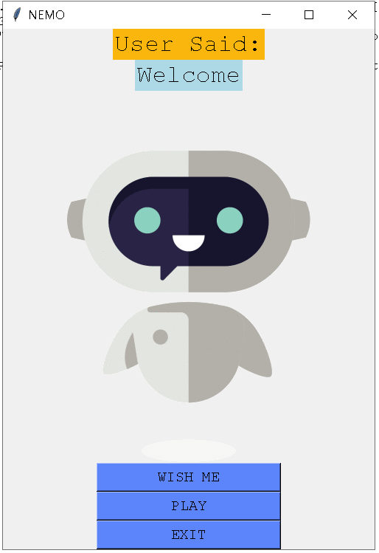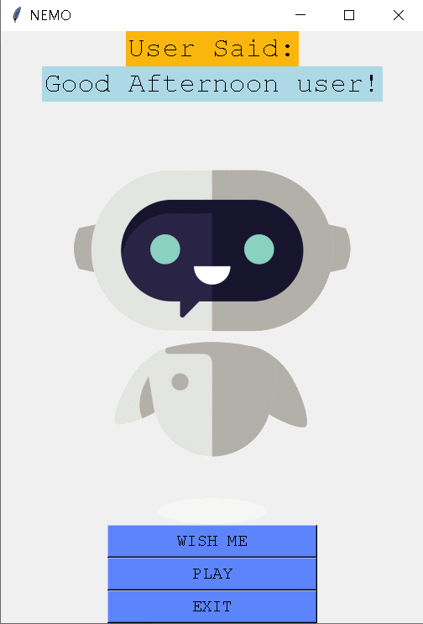
Fig 7.1:Home Page Fig 7.2:Wish Me Feature
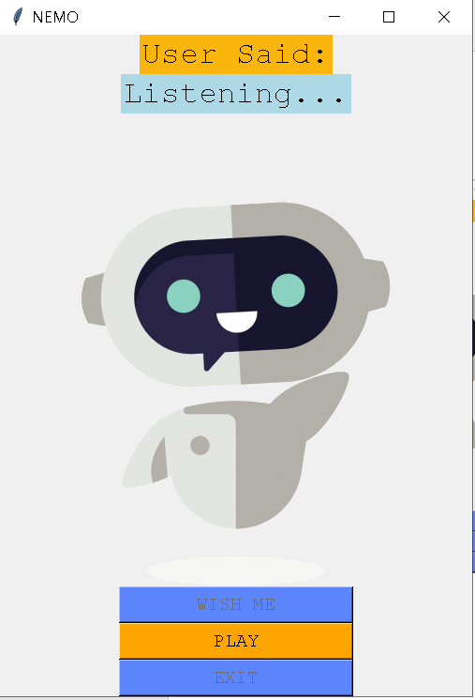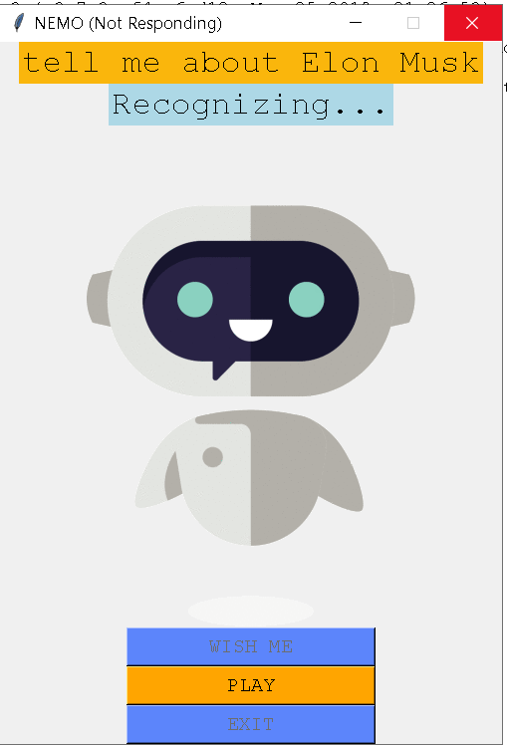
Fig 7.3:Voice Assistant waiting for user Voice Command Fig 7.4:Recognizing Voice Command

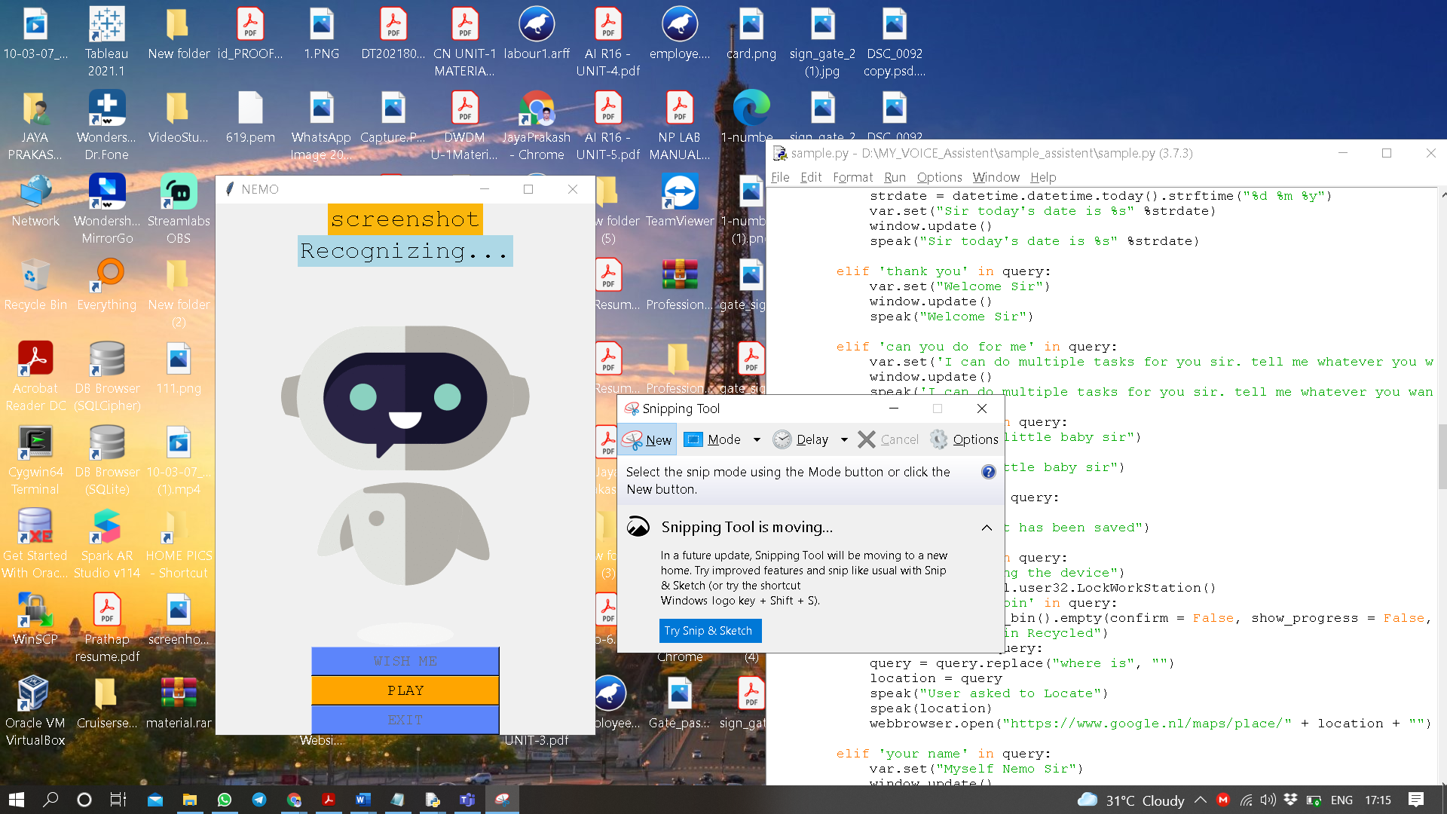
Fig 7.5: Output for “Take a Screenshot” Voice Command

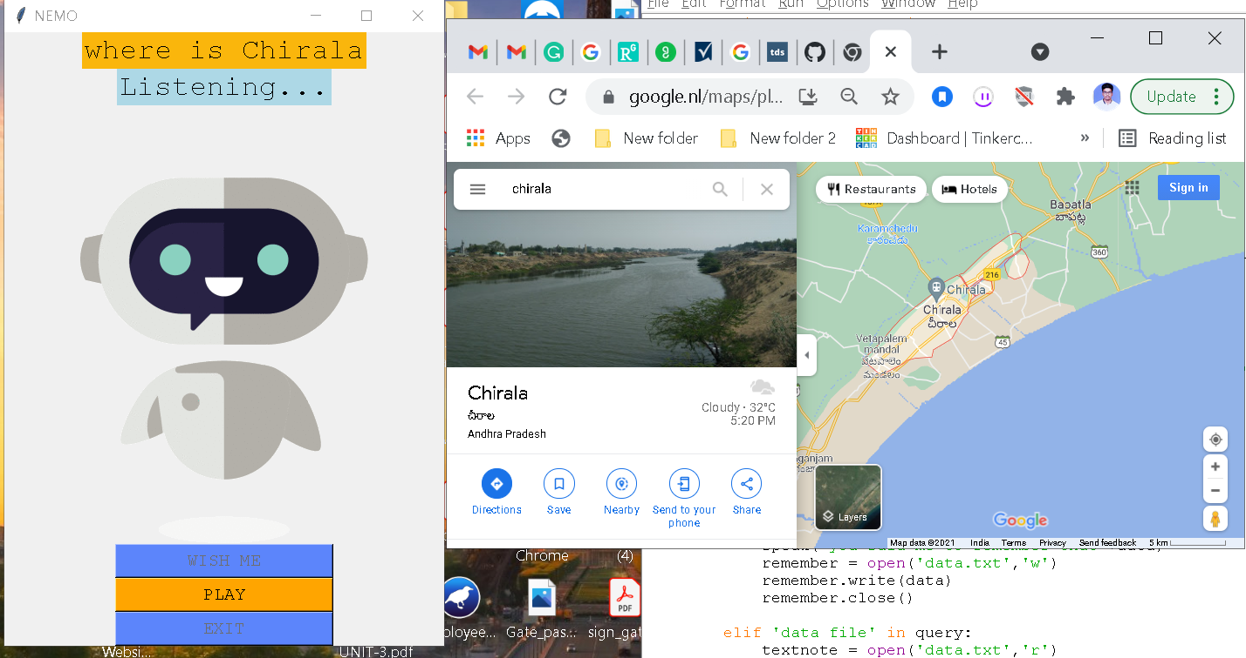
Fig7.6: Output for “Where is Chirala” Voice Command

CHAPTER – 8
CONCLUSION
Furthermore, we compared the proposed system with existing systems, and it comparably out performed the others.we mean regarding personal voice assistant in PC ,Laptop.The features we Implemented in this voice assistant is connecting to maps , taking selfie , taking notes and many more features are new to the existing system.We can make even more advancements in this project and this AI voice assistant is Rule Based System , Further we can make connect to database and do more Interactively.
The main agenda of our voice assistance makes people smart and gives instant and computed results and also automates our routine generalized works. The voice assistance takes the voice input through our microphone (Bluetooth and wired microphone) and it converts our voice into computer understandable language gives the required solutions and answers which are asked by the user. This assistance connects with the world wide web to provide results that the user has questioned. Natural Language Processing algorithm helps computer machines to engage in communication using natural human language in many forms.

CHAPTER - 9
FUTURE SCOPE
- In future we want to work on transforming this Rule Based learning to Reinforcement Based AI model and make it huge and more Interactive for users.
- And also we decided to make it as multi-user application, use of a single database and start providing services to companies like Microsoft.
- In Future we also give labelling and self-learning capability and many more features to this application.

CHAPTER - 10
REFERENCES
[1] S R. Belvin, R. Burns, and C. Hein, “Development of the HRL route navigation dialogue system,” in Proceedings of ACL-HLT, 2001.
[2] V. Zue, S. Seneff, J. R. Glass, J. Polifroni, C. Pao, T.J.Hazen,and L.Hetherington, “JUPITER: A Telephone Based Conversational Interface for Weather Information,” IEEE Transactions on Speech and Audio Processing, vol. 8, no. 1, pp. 85–96, 2000.
[3] M. Kolss, D. Bernreuther, M. Paulik, S. St¨ucker, S. Vogel, and A. Waibel, “Open Domain Speech Recognition & Translation: Lectures and Speeches,” in Proceedings of ICASSP, 2006.
[4] Core Python Programming, W.Chun, Pearson.
[5] Python Programming: A Modern Approach, Vamsi Kurama, Pearson.
[6] Hirschberg, Julia, and Christopher D. Manning. “Advances in Natural Language Processing.” Science 349 (6245): 261–266. doi:10.1126/science.aaa8685..
[7] Moore, Clayton. “The Most Useful Skills for Google Home.” Digital Trends (May 3, 2017).
[8] Spence, Ewan. “Windows Phone Is Dead, Long Live Microsoft’s Smartphone Dream.” Forbes (July 12, 2017).
[9] Lee, Nicole. “Google Assistant on the iPhone Is Better than Siri, but Not Much.” Engadget (May 17, 2017).
https://www.engadget.com/2017/05/17/google-assistant-iphone- hands-on/

